Student’s Name
Organs Transplant
Professor’s Name
Date

Organ trade relates to the trade of human organs. According to the research done by the world health organisation, there are more organs required for transplant than available. In most cases, most people have kept waiting lists sometimes for years in health centres. An average of 400 people in the United States dies awaiting a transplant. Due to this, some people sort out to resort to illegal means to receive a transplant (Becker and Julio 2017, 20). This illicit means may be through the purchase of body parts for example eyes, kidneys, heart, lungs for operation on the black market. Organ trade is strictly regulated in the US, but on the contrary, the black market is alive and well.
In the United States, many people need kidneys than the supply of the available organs. Consequently, the waiting list in health centres for a kidney has reached nearly 100,000 people. Studies from the Health Resources and Services Administration shows that only between 16000 and 17000 kidneys are transplanted each year. Economist has argued that whether offering people financial incentives to donate organs might be the best way to address the mismatch between supply and demand. Besides, growing evidence from trials in other areas of medicine suggests that financial incentives are a potential way to improve national health (Matas 2014, 2016).
There is a large gap between deceased donation and the existing demand in the corporate world. On the same, living donors are much required to meet the requirement that is out there. Kidneys are among the few organs where the living donation is feasible. Many people are healthy enough to live a problem free with only one kidney (Weimer 2017, 120). Besides, around a third of the kidney transplants come from living donors. Such kidneys lead to better outcomes with living donations lasting as twice as those that come from deceased donors. Despite the many multifaceted methods to get people to donate kidneys various approaches to increase organ procumbent has not succeeded.
According to the National Organ Transplantation Act that prohibits the sale of organs for transplantation, the only way is through the donation of organs (Weimer 2017, 120). The effects of the law are understood well on the supply and demand for kidneys. Consequently, even for zero donors supply 8000 kidneys per year. Similarly, many other people who need kidney transplants cannot obtain them because of the lack of donors. An estimate of 4000 more organs would be supplied if the price was $ 200,000. This shows the following linear supply curve; QS= 8000+ 0.2P.
It is much expected that for $20,000 the demand for kidneys would be 12,000 per year. Moreover, like supply, demand is relatively priced inelastic. This describes a reasonable estimate for the elasticity of demand at $ 20,000 price is -0.33. This implies the following demand curve: Demand: QD= 1600= 16,000-0.2P.
Payment for living kidney donation is illegal in the United States. Again legislation is needed to shorten waiting times. In our state today the biggest problem in kidney transplantation is the shortage of organs. If there is payment in kidney donation rather than being free will, this will not be called a contribution. Several issues will emerge when there is the sale of organs. There are several arguments in favour of prohibiting the sale of organs. One of the cases stems from the problem of imperfect information. This means that if people received payments for organs, they might hide antagonistic details about their health histories. For instance on the sale of blood where there is a possibility of transmitting hepatitis AIDs and other viruses. Again, in the deregulated market for kidney, there will be no compensation (Matas 2014, 2016).
If the kidneys can be bought and sold on a free market, then the number of organs coming into the market will be responsive to price. In the graph, the number of kidneys supplied equals the number donated voluntarily, QR. The market clearing price occurs at P4. The competitive equilibrium output is QC. Therefore, all individuals who require kidney will be able to acquire one on the competitive market.
Furthermore, a free market of kidneys, in conjugation with the current system of financing transplants eliminates the medical shortage. This implies that no person who could benefit physically benefit from a kidney transplant would need to go to one. In the free market, the prices of kidneys would be determined by the open a market and the consumers. In summary, price ceiling places a maximum upper bound on the market price. It creates a shortage of kidneys and binding if the equilibrium is relatively higher.
Due to the implications of changes in the current policies, some people gain from the hypothesized policy alternatives, and some become losers in the market. In the graph one, the act prohibits the sale of kidneys that is limited to 8000 which is the number of kidneys that people donate. The current market for kidney allows recipients to gain more (Becker and Julio 2017, 20). The act treats the kidney as a gift to the recipient. Those who obtain kidneys gain rectangle A. ($160 million) because they don’t have to pay the $20,000. On the contrary, those who cannot obtain kidneys lose an amount given by triangle B equals to $ 40 million.
On the other side of the suppliers, are the one who loses on the current market of the kidney. From the graph 1, those who provide kidneys fail to receive the $ 20,000 each kidney is worth. This loss is represented by rectangle A. From the figure, the total amount of the supplier’s loss is worth$ 200 million. In the deregulated market, on the contrary, the government not engaging as the third party the suppliers are the one that loses. The economic state of the market is that the voluntary market out ways a mixed case of public and private provision. For instance, if the kidney provided in the mixed case can be distributed without any rent-seeking costs; therefore no dissipation of surplus cost will exist between demand and supply prices. After deregulation, there will be marginal external benefits in the market (Weimer 2017, 120).
Many countries in the world have implemented policies that govern the purchase of market. Some include routine removal, presumed consent and organ donor points among others. These policies have limitations on the current state of kidney transplant market — for example, the organ donor policy where there is no authorization from the recipient. Thus there is no research on the donated organs before transplantation. Again, no recent prior consent would show if he or she accepts the donation. Therefore obtaining authorization from organ donors is an essential requirement. The policies fare in equity and efficiency in several circumstances (Weimer 2017, 120).
A good example is where the authorization has to be conducted to organ donors. Again the deadweight underestimates the true efficiency cost of the policy. This is because kidneys not necessary be allocated to those who value them most highly.
In the state, there is a significant shortage of kidneys. In the in the country, this estimates to 70,000 people a year for people who must replace failing kidneys. The ethical policy of presumed consent in the current state of the market would help to reduce the shortage of kidneys. Thus the demand curve for the kidneys showing the number of kidneys demanded at each price would be negatively sloped. On the side of the supply curve, the curve will be positively sloped. It suggests at that at higher prices more prospective donors will step forward to sell their kidneys (Taylor and Stacey, 2017). The impact on the society is that in the free market for kidneys the government as the third party economic and medical shortage will be eliminated. Therefore, everyone will benefit physically from the kidney transplant. Using the demand and surplus curve, the means to reduce the shortage of kidneys is by having an equilibrium point.
I recommend the presumed consent policy in the current systems to help in combating the shortage of kidneys. The policy will favour both the poor and wealthy based on ethical reasons. In this context, there will be an elimination of medical scarcity as well as an economic deficit. This will eliminate the need to ration kidneys.

References
Becker, Gary S., and Julio Jorge Elias. "Introducing incentives in the black market for live and cadaveric organ donations." Journal of economic perspectives 21, no. 3 (2017): 3-24.
Matas, Arthur J. "The case for living kidney sales: rationale, objections and concerns." American journal of transplantation 4, no. 12 (2014): 2015-2017.
Taylor, James Stacey. Stake and kidneys: why markets in human body parts like kidneys to be morally imperative. Routledge, 2017.
Weimer, David L., and Aidan R. Vining. Policy analysis: Concepts and practice. Routledge, 2017.

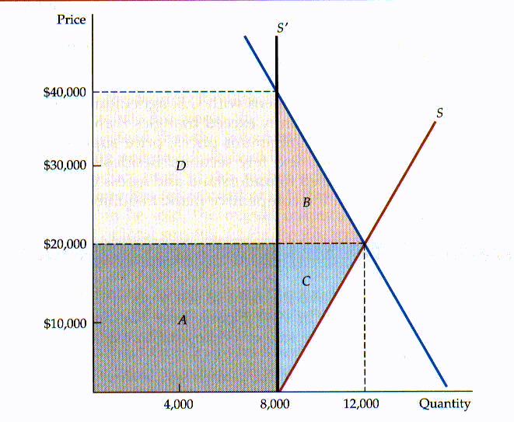
GRAPH 1

GRAPH 2

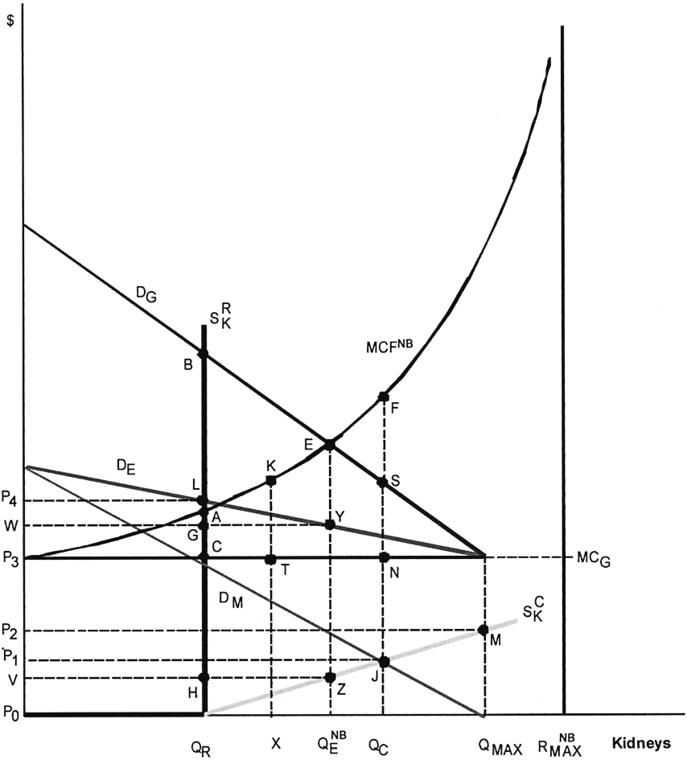

GRAPH 3

